Photographs by famous photographer and progressive reformer, Lewis Hine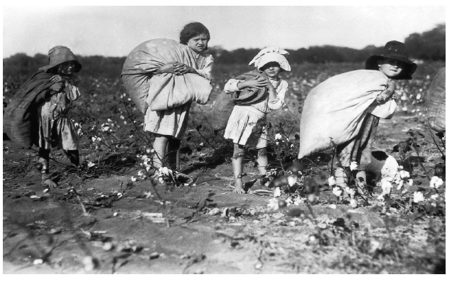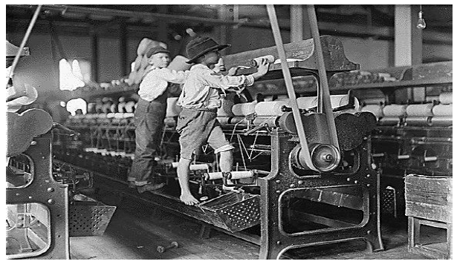 – c1908.